Please populate the blanks

Easy Breeze booking form
A&E Adventures
Event Décor Design and Build

Date: 04.03.2017
Clients Details
Full Name / Company Name:
Invoice Addressee:
Home / Company Address:

Postcode:
Tel:
Email:
Event/Venue/Delivery Details
Date of Event:
Date for Flag Delivery:
PLEASE return flags, poles etc as soon as possible after your event.

Return address: A&E Adventures Ltd, Greenhill, Caerfarchell, Solva, Haverfordwest, SA62 6XG.
Location of Delivery: | Company / Home / Venue
Venue Address:

Postcode:
Tel:
Venue Contact Name:

Flag Details

Item | Description | Price per Unit | Quantity
Easy Breeze flags | Pinks | £28.00 + Vat
 | Greens | £28.00 + Vat
 | Blues | £28.00 + Vat
 | Purples | £28.00 + Vat
 | Yellows | £28.00 + Vat
 | Reds | £28.00 + Vat
 | Oranges | £28.00 + Vat
 |  | TOTAL FLAGS
5m fibreglass telescopic poles and ground stakes included, 1 with each flag.
PLEASE email info@aandeadventures.co.uk with this booking form. On receipt of this completed form we will issue an invoice including one way postage for full payment. Your order will not be confirmed until payment has been received. Return postage and payment must be organised by the client. Terms & conditions of hire are on the invoice to follow.

Multi coloured Easybreeze flags flying in the sunshine

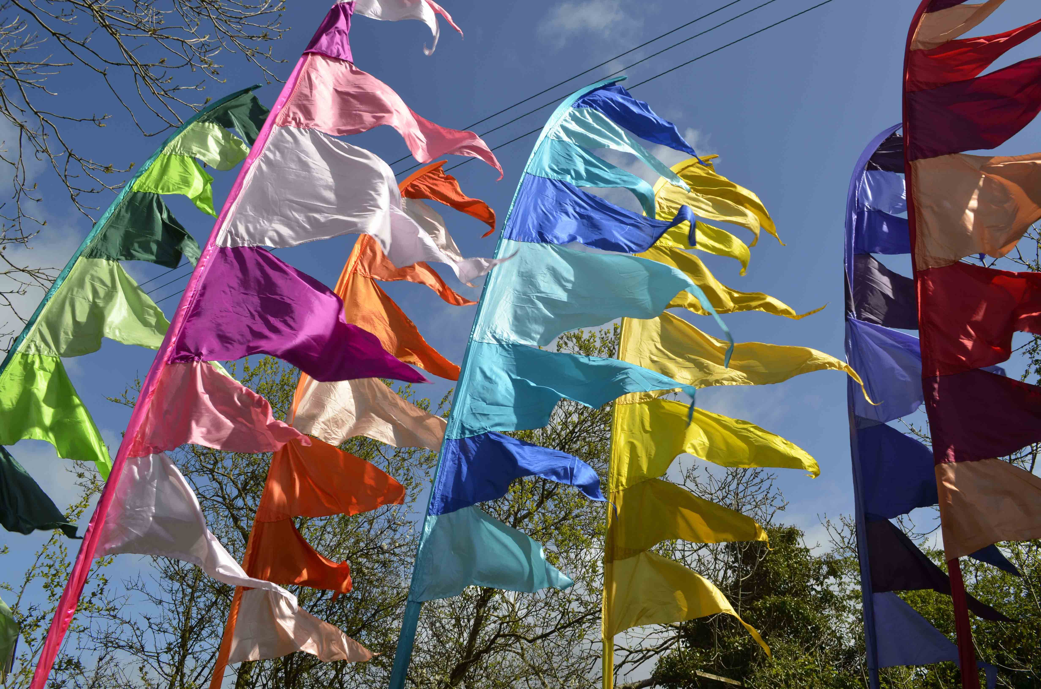

Thank you for decorating with A&E Adventures Ltd

